Azure Data Factory (ADF)
1. Introduction to Azure Data Factory
What is ADF?
- Cloud-based ETL/ELT service
- Orchestrates data movement + transformation
Core Components
- Pipeline → logical workflow
- Activity → task inside pipeline
- Dataset → data structure
- Linked Service → connection

2. Pipelines & Activities
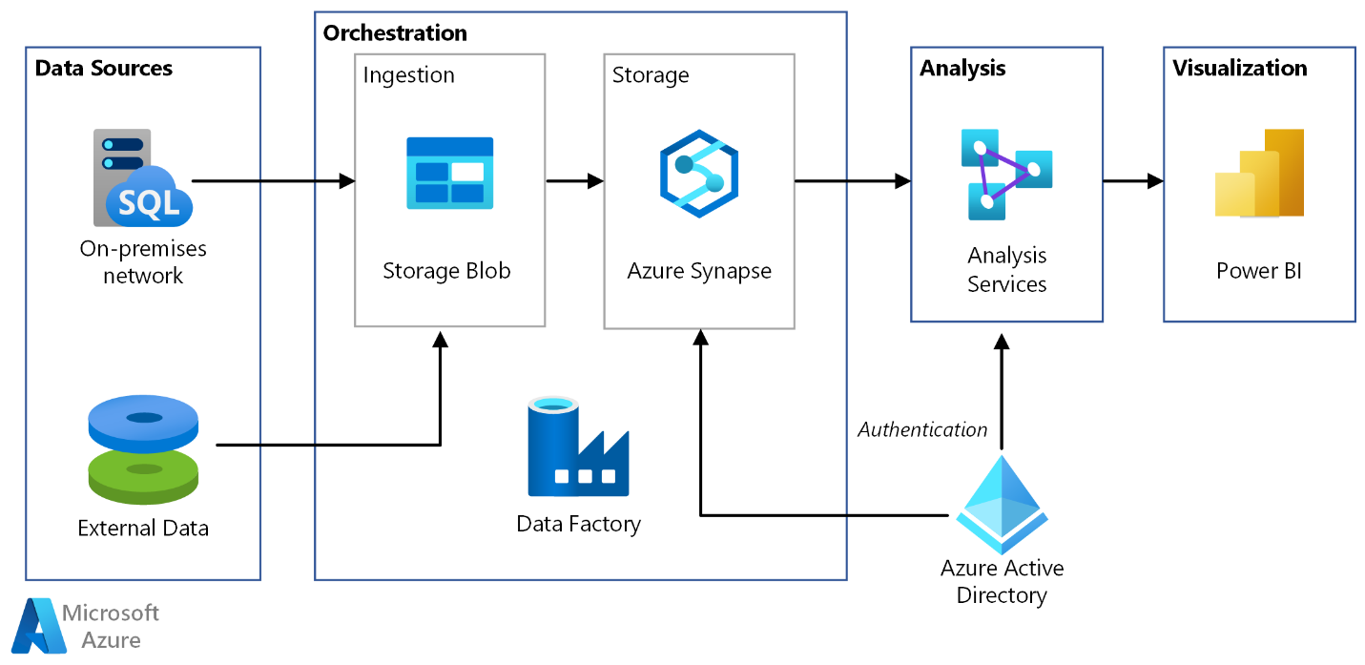
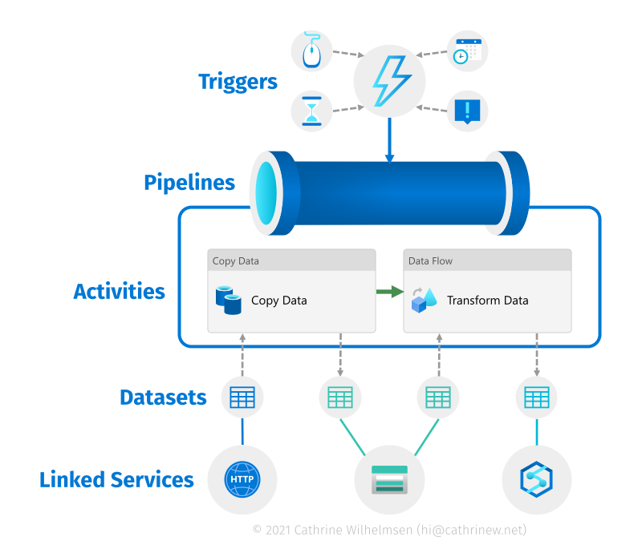
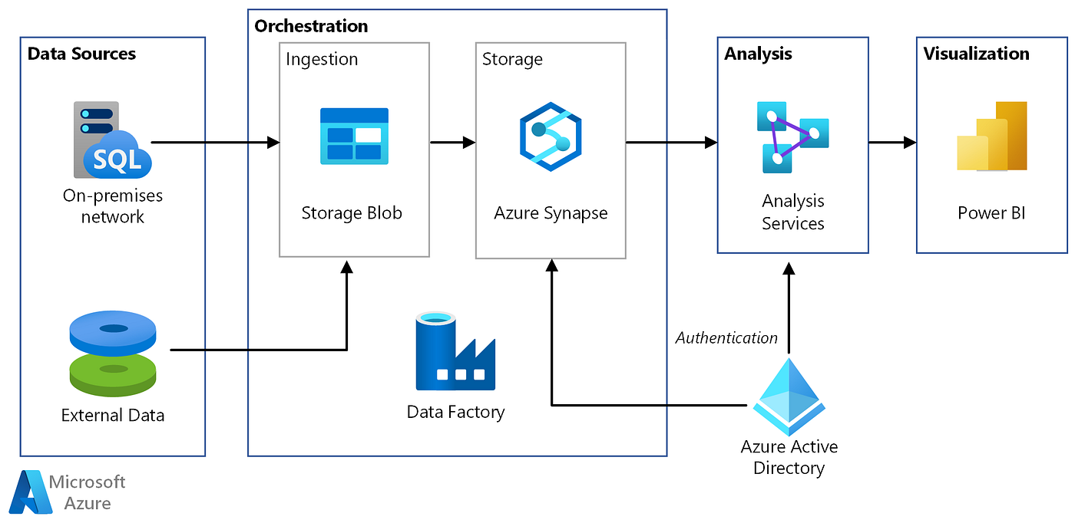
Explanation
- Pipeline = container of activities
- Activities types:
  - Data Movement (Copy)
  - Data Transformation (Data Flow, Databricks)
  - Control (If, ForEach, Wait)

3. Copy Activity (Core Concept)
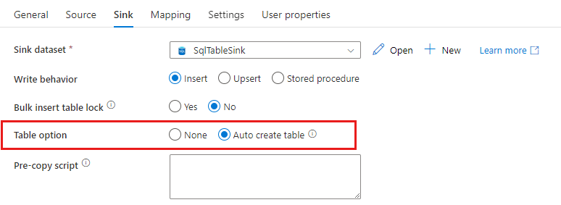
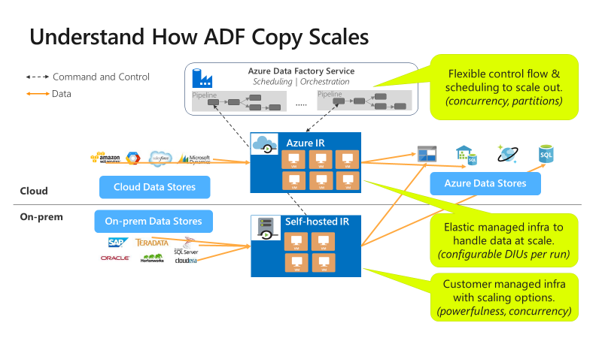
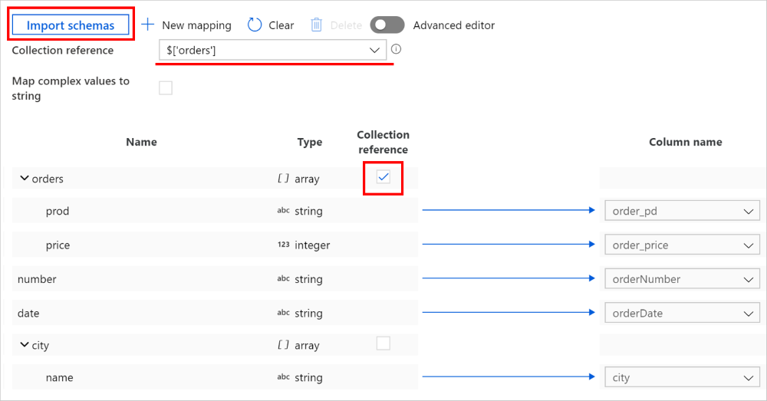
Explanation
- Moves data from source → sink
- Supports 100+ connectors
Important Concepts
- Source dataset
- Sink dataset
- Mapping (auto / manual)
Demo Flow
- Source: CSV (Blob)
- Sink: ADLS /bronze/sales/
- Run pipeline
Interview Insight
- Copy activity = lift-and-shift ingestion

4. Integration Runtime (IR)
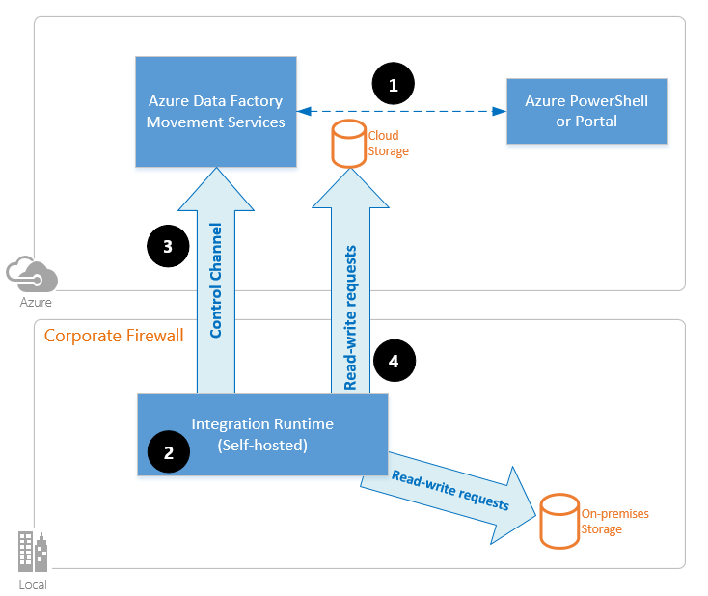
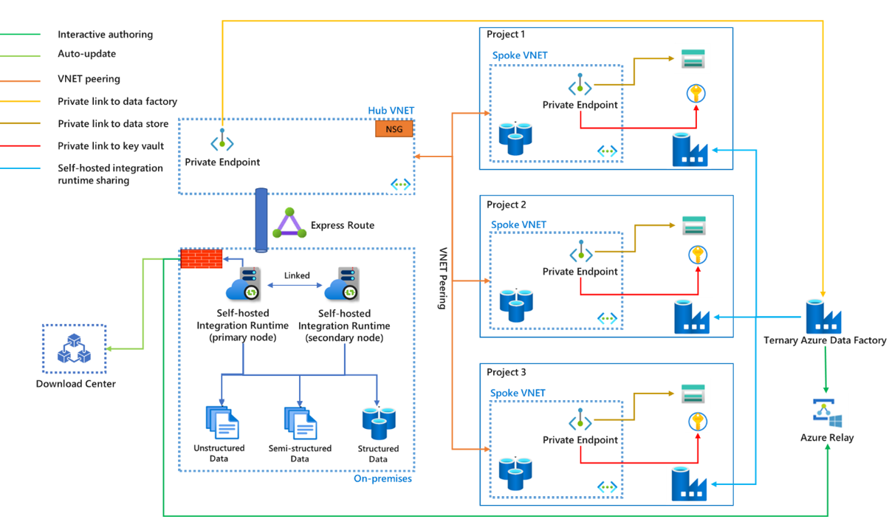
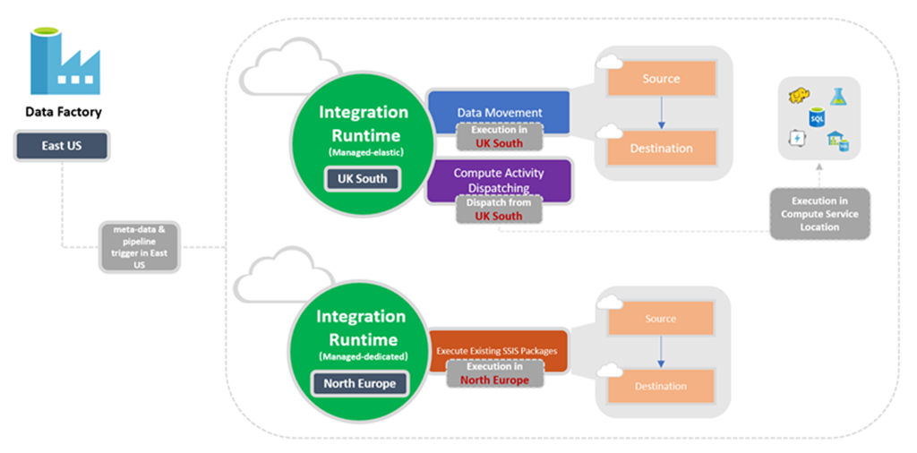
Types
- Azure IR → cloud
- Self-hosted IR → on-prem
- SSIS IR → legacy workloads
Key Points
- Responsible for data movement + compute
- Defines where pipeline runs

5. Mapping Data Flows (Transformation)
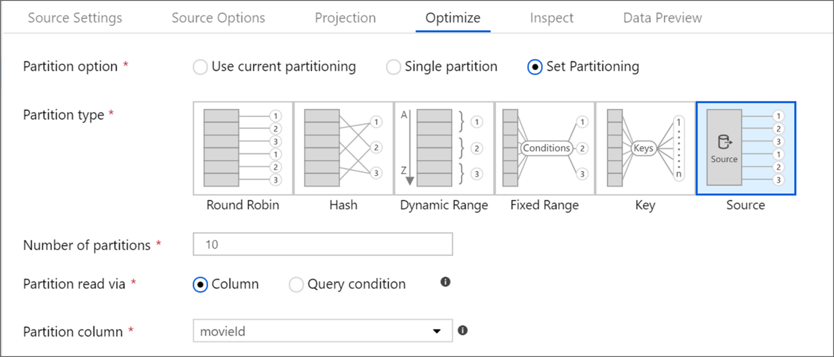
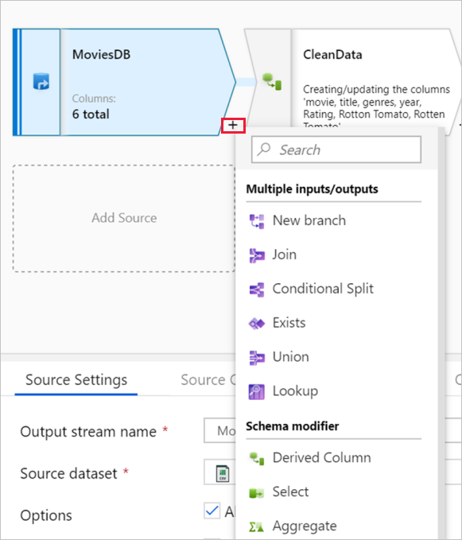
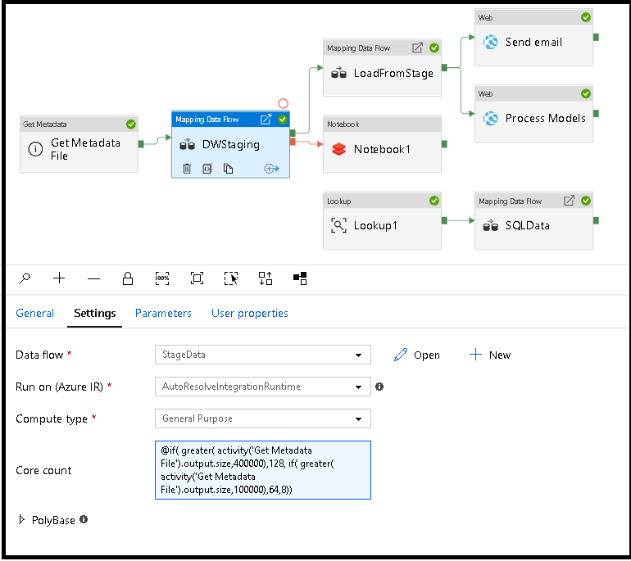
Explanation
- No-code Spark-based transformations
- Runs on managed clusters
Transformations
- Filter
- Derived Column
- Join
- Aggregate

6. Parameterization (Dynamic Pipelines)
Why?
- Avoid hardcoding
- Reusable pipelines
Types
- Pipeline parameters
- Dataset parameters
- Global parameters
Demo Example
@concat('bronze/sales/', pipeline().parameters.fileName)
Scenario
- Same pipeline processes multiple files
Key Insight
- Parameterization = Production readiness

7. Triggers & Scheduling
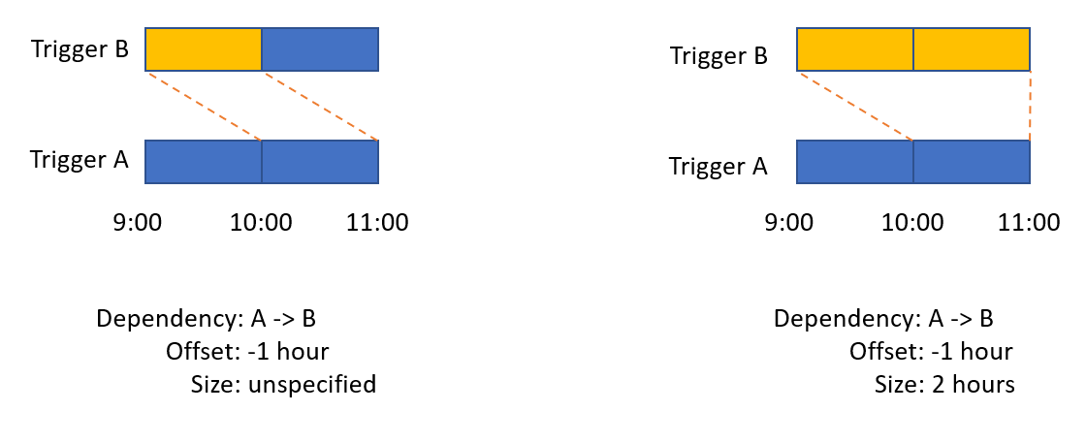
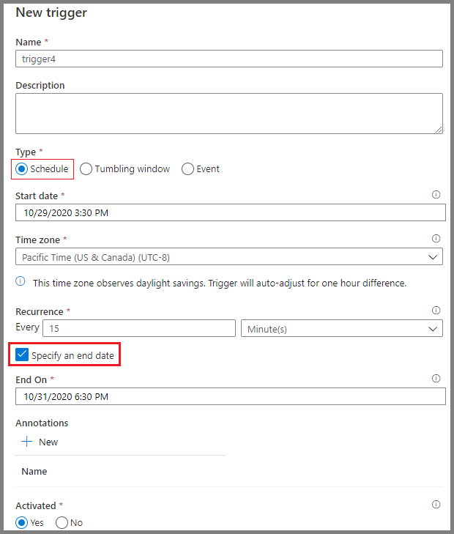
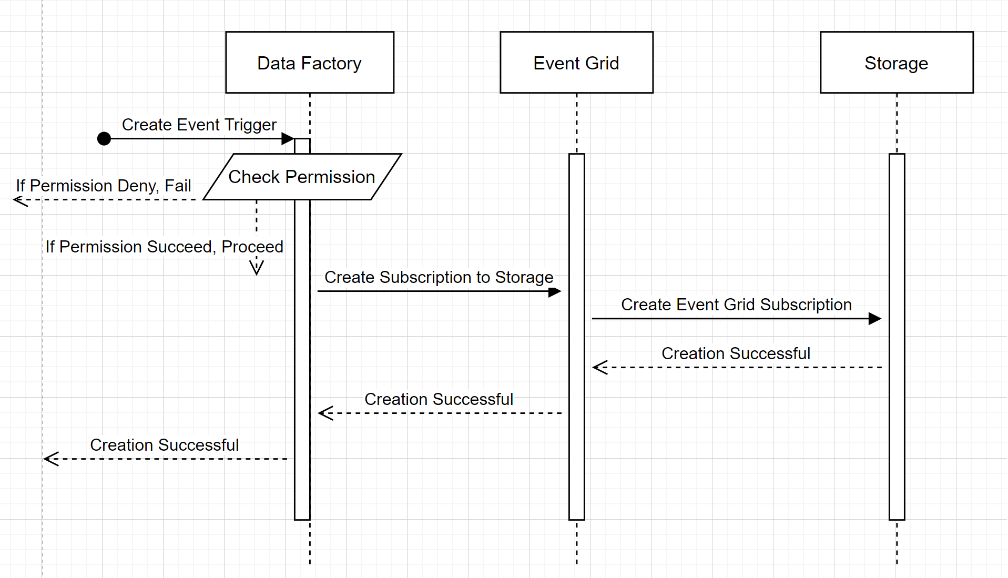
Types
- Schedule → time-based
- Event → file arrival
- Tumbling Window → batch processing

8. Monitoring ADF
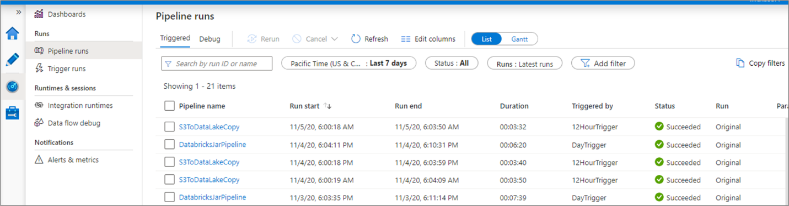
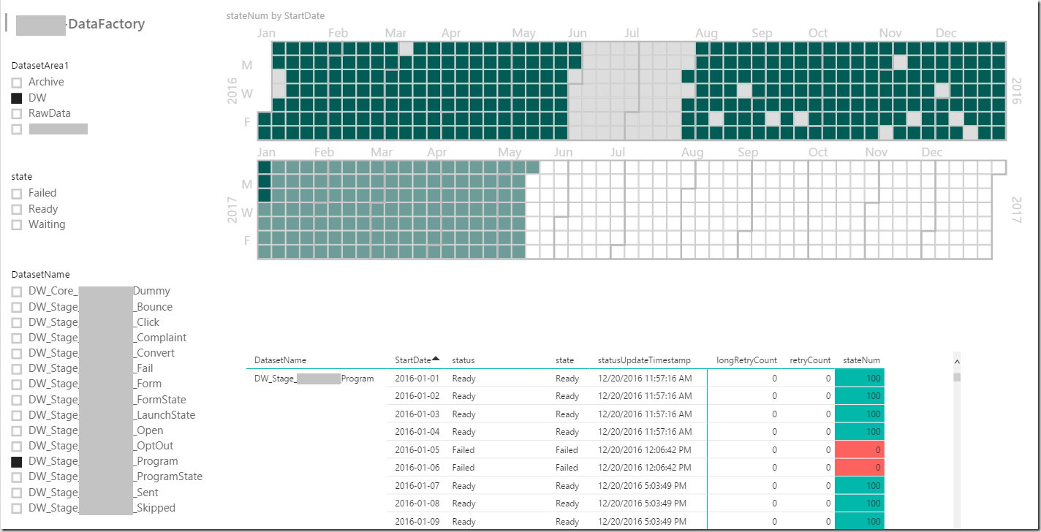
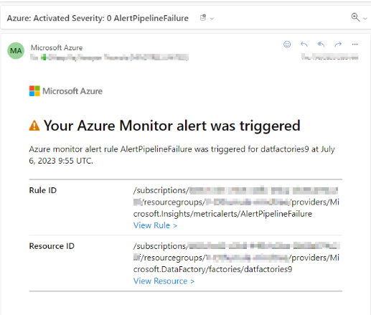
Features
- Pipeline runs
- Activity logs
- Error tracking

Module 7 — Azure Databricks (Integration Focus)
1. Azure Databricks Overview
What is Azure Databricks?
- Apache Spark-based analytics platform
Role in Architecture
- ADF → Orchestration
- Databricks → Processing

2. Workspace Deployment
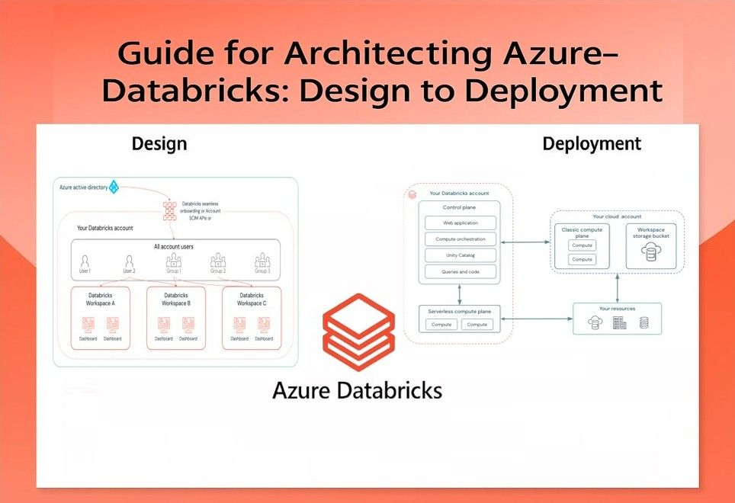
Steps
- Create resource in Azure Portal
- Choose pricing tier (Premium recommended)

3. Cluster Configuration Best Practices
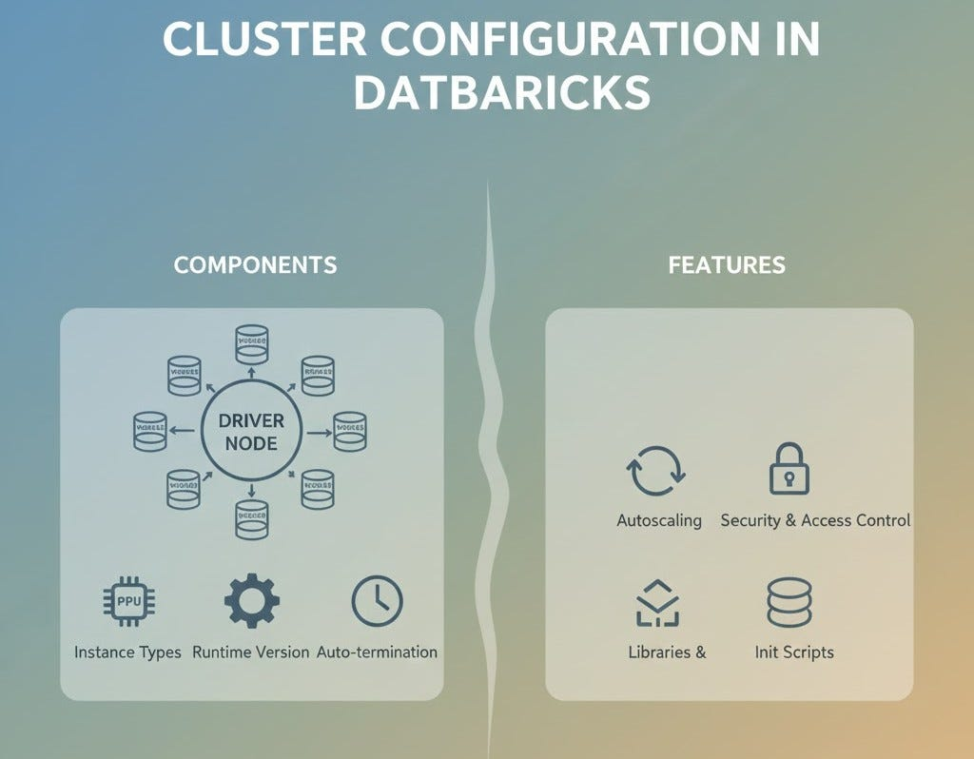
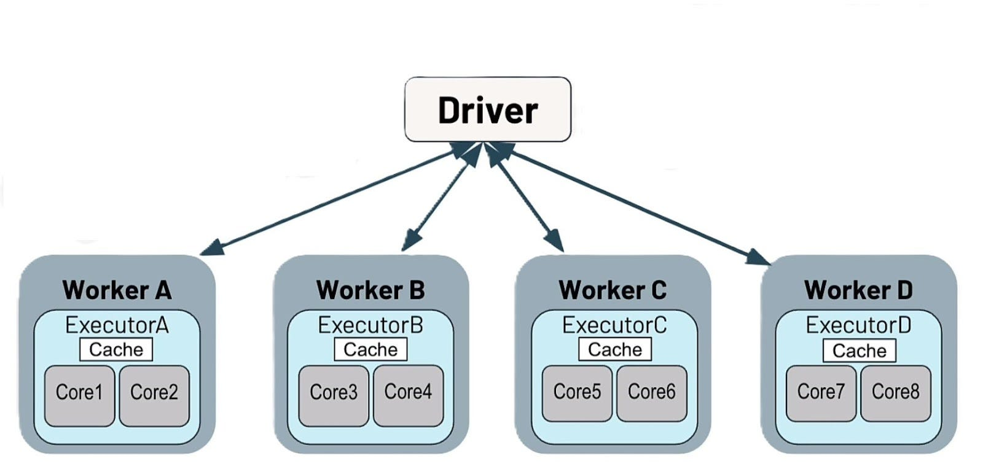
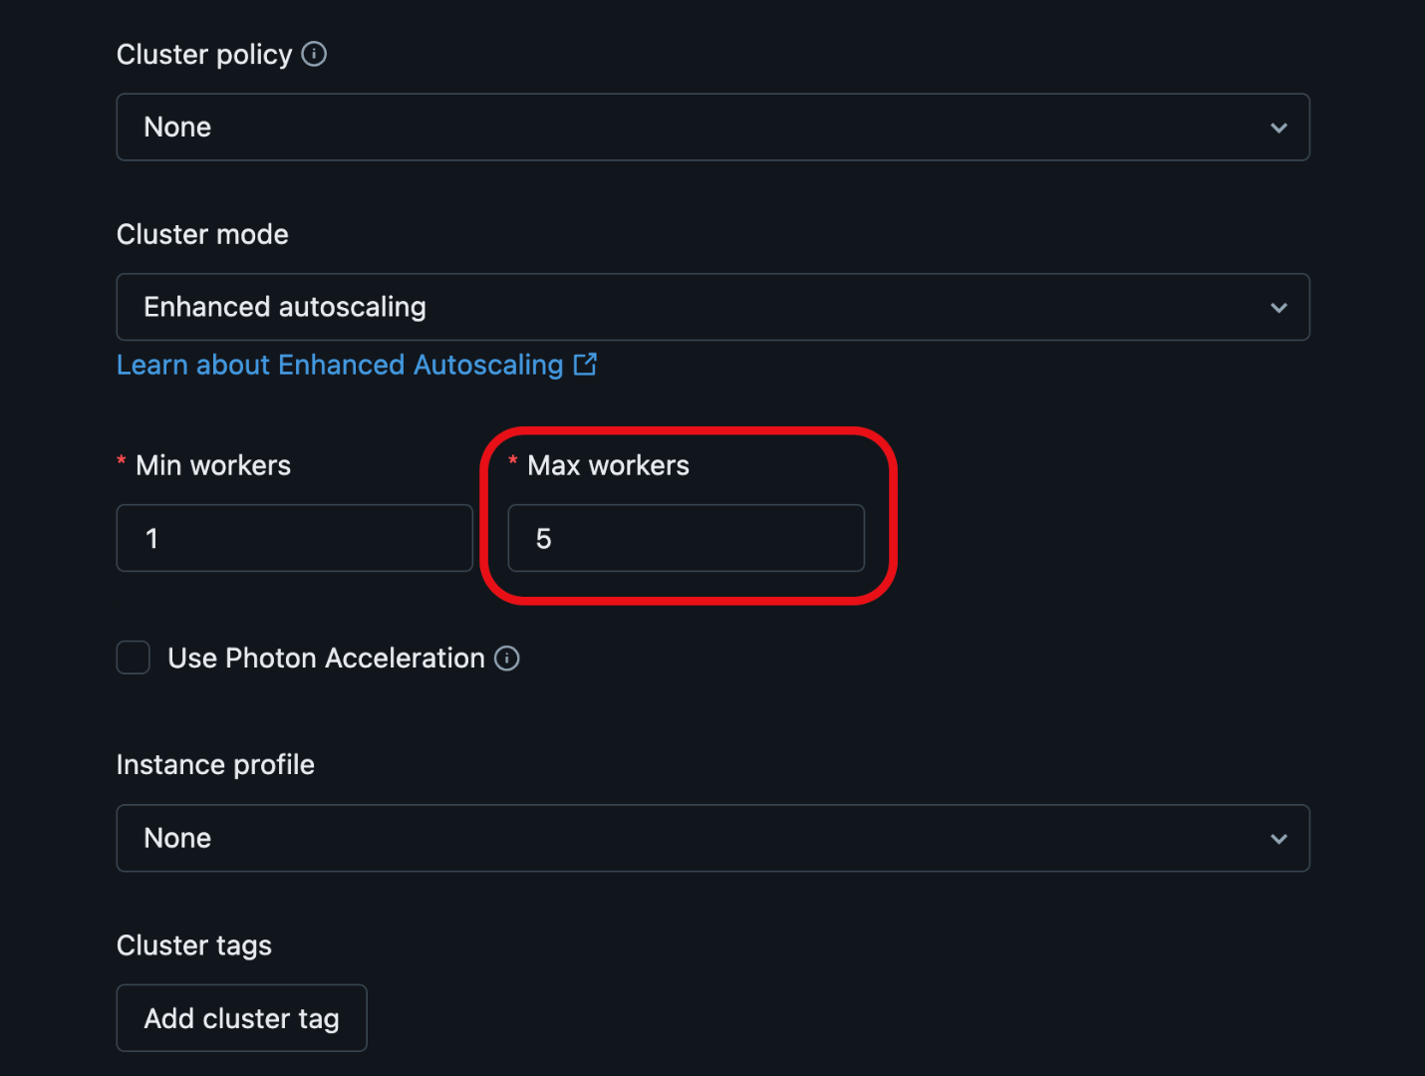
Key Settings
- Auto termination
- Autoscaling
- Node types
Best Practices
- Use job clusters
- Enable Photon
- Avoid idle clusters

4. ADLS Mounting Patterns
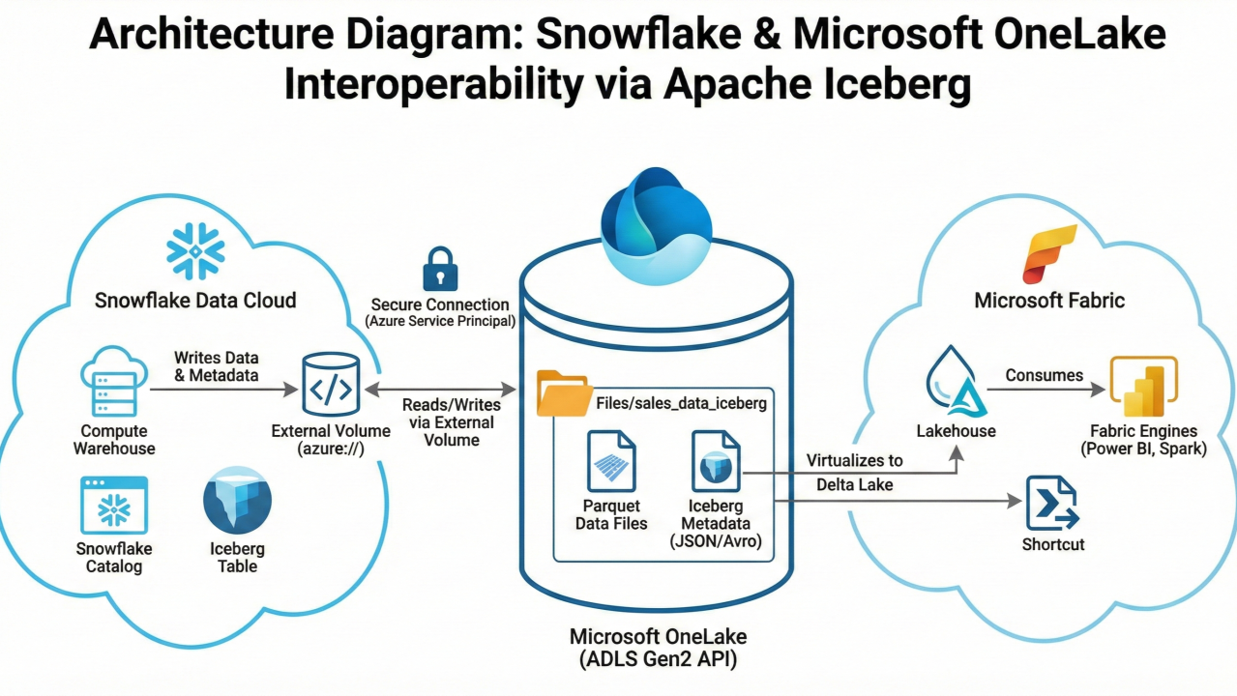
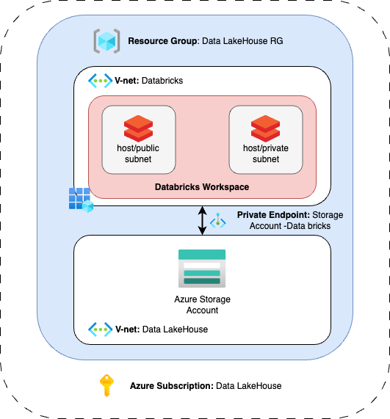
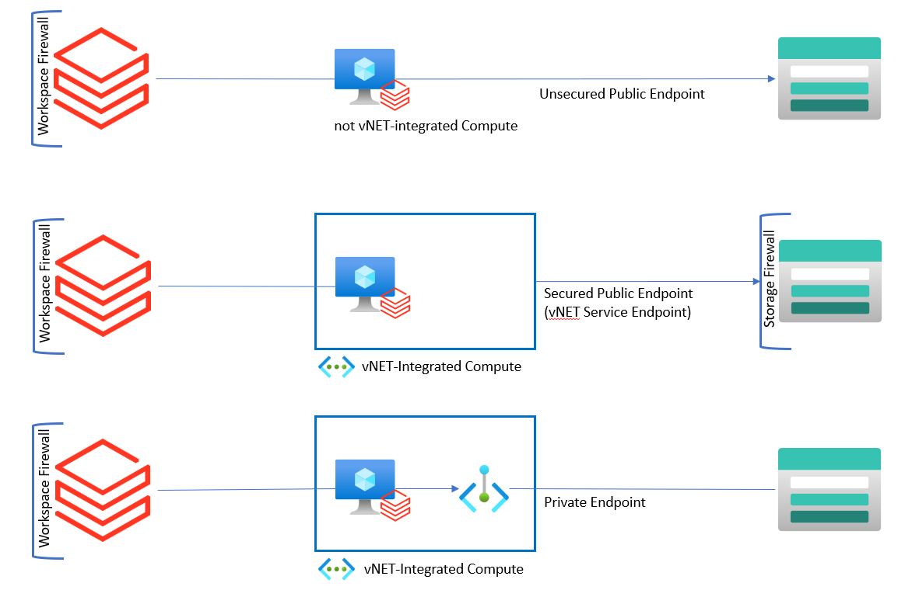
Methods
- Service Principal (recommended)
- Managed Identity
- Direct access (abfss)
Key Insight
- Mount = persistent access layer

5. Managed Identity Integration
Why?
- Avoid secrets
- Secure access
Steps
- Assign role: Storage Blob Data Contributor
- Access ADLS securely
Key Insight
- Best practice for enterprise security

6. Secure Networking (Private Link)
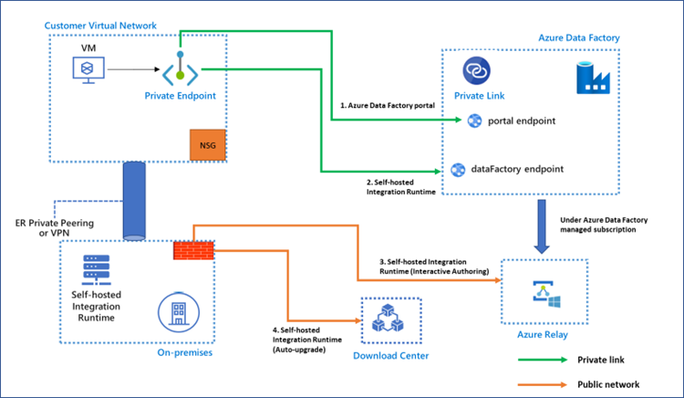

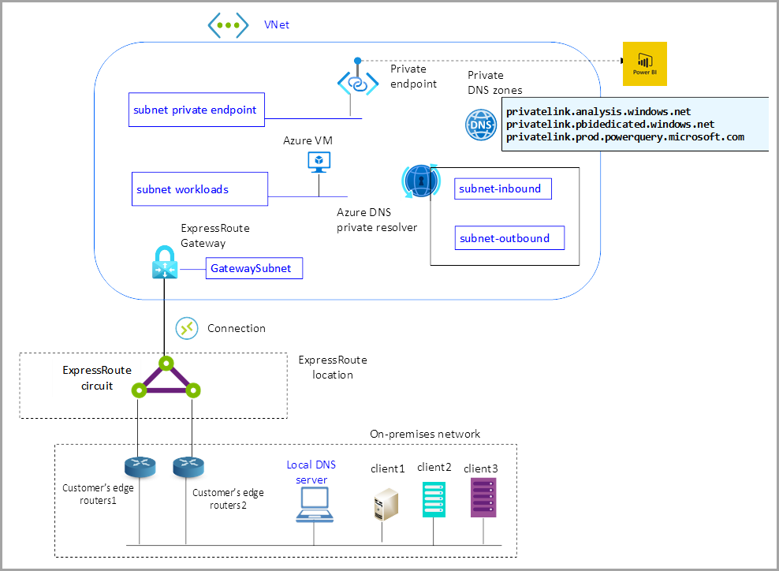
Concepts
- VNet injection
- Private endpoints
- No public exposure
Real Use Case
- Banking / healthcare environments

7. Cost Optimization Patterns
Techniques
- Auto termination
- Spot instances
- Optimize file sizes
Anti-patterns
- Small files problem
- Always-on clusters

8. Production Deployment Patterns
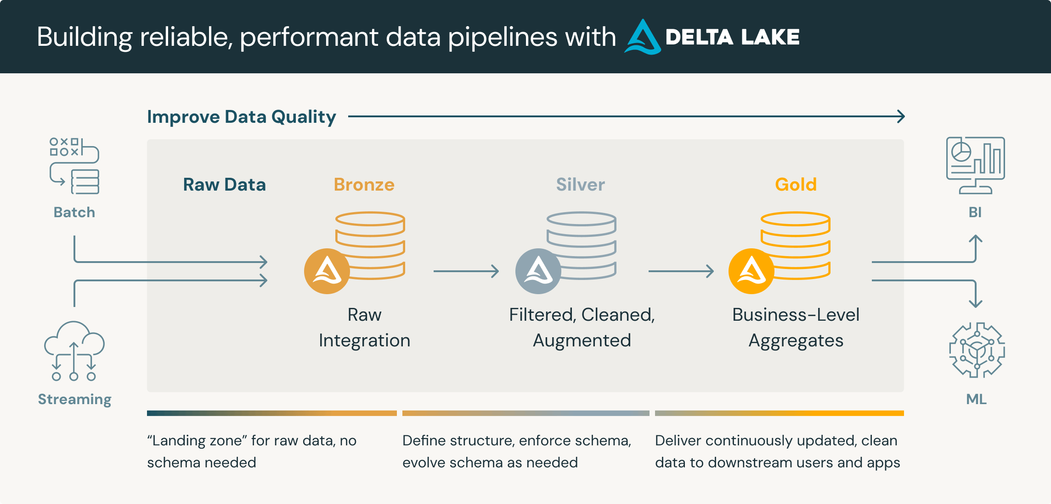
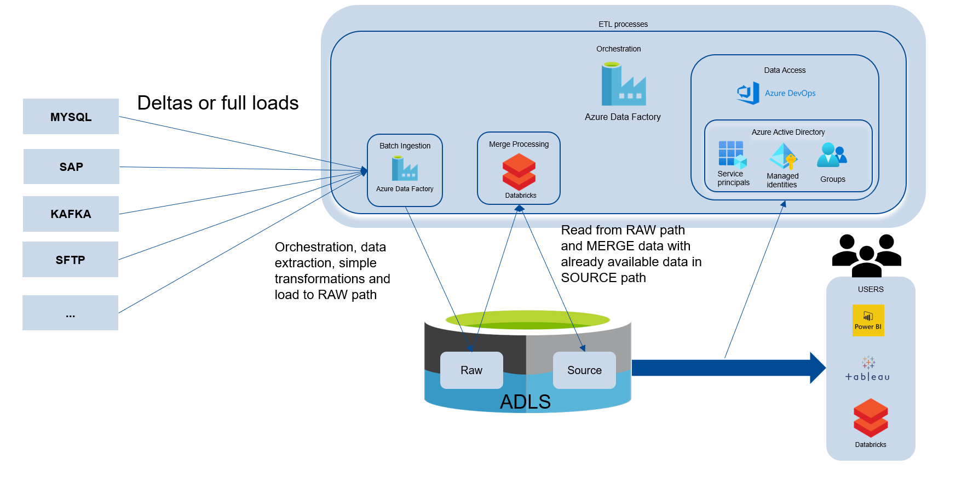
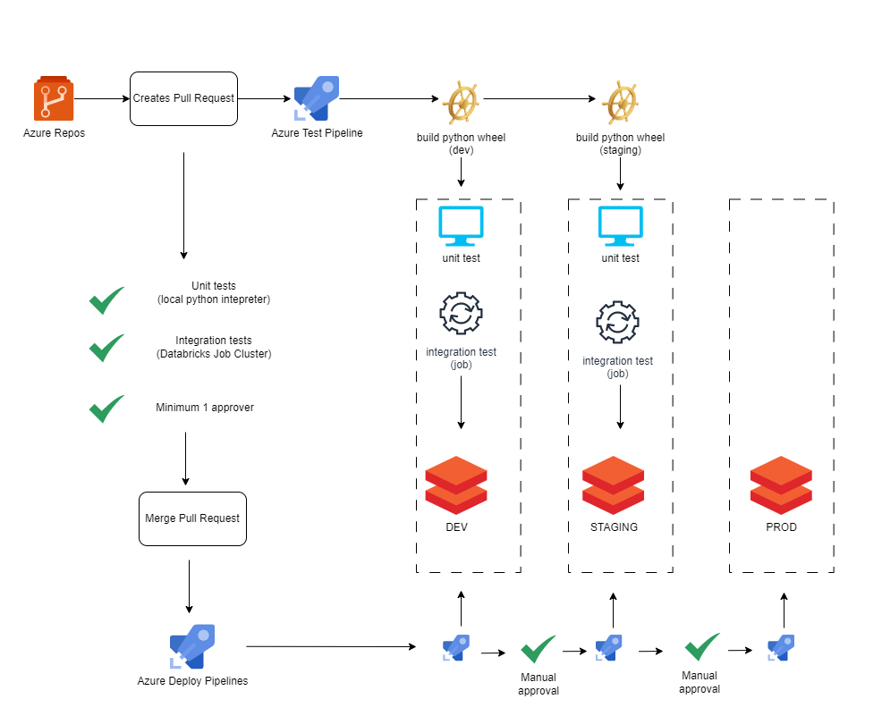
Architecture
- Bronze → Silver → Gold
Integration
- ADF triggers Databricks notebooks
CI/CD
- Dev → Test → Prod
- Git integration
Key Insight
- Separation of concerns:
  - ADF = orchestration
  - Databricks = compute

